- What is a payment gate-way also discuss how does it Works. ( 3 marks)
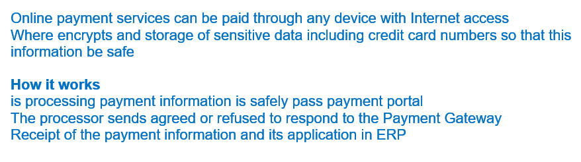
- Name the three most vulnerable points in e commerce environment and also discuss why these points are so vulnerable and what is the solution? ( 3 marks)
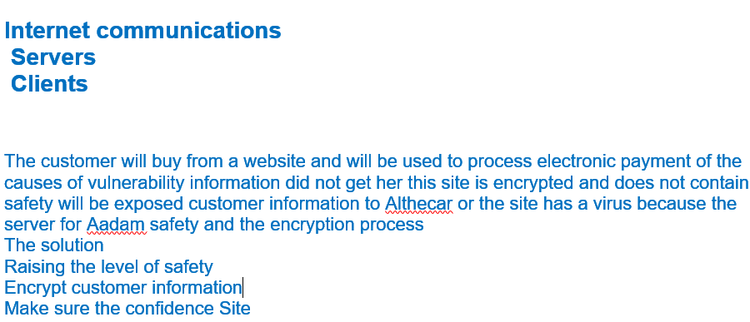

- What are the factors that Influence Consumers’ Buying Behavior also mention Stages in the Buying Process. ( 3 marks)
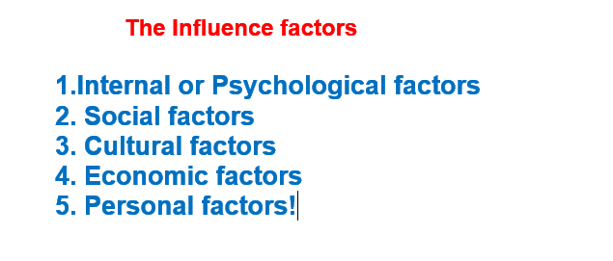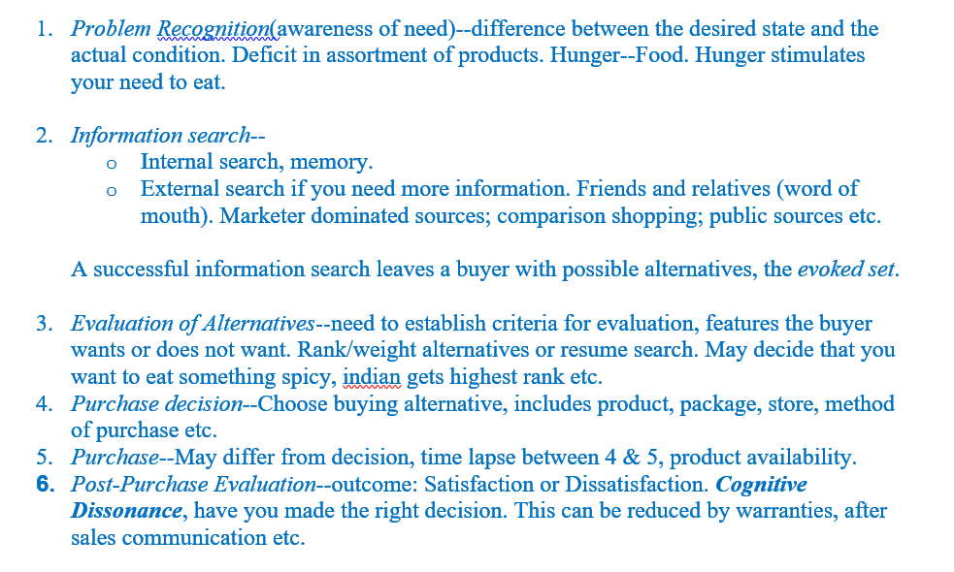

- Discuss the 10 most Important Website Attributes. ( 3marks)

- What do you understand by motivation also discuss Maslow’s Hierarchy needs. ( 3 marks)
